Classification – The Five Kingdom System
Living things with characteristics in common are grouped together firstly into kingdoms. Currently scientists agree on five different kingdoms – Monera, Protista, Fungi, Plant and Animal.
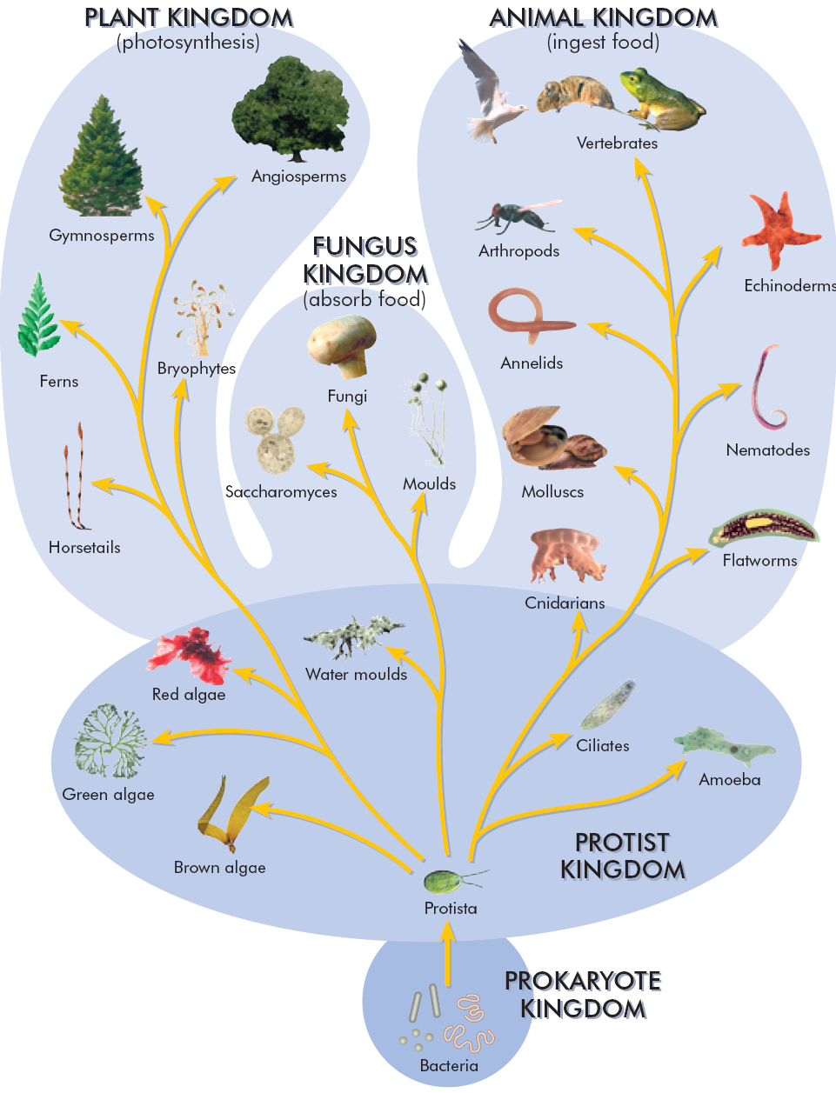

Kingdom Monera
All the prokaryotic organisms, whose cells do not have a nucleus are in this kingdom.
Prokaryote cells do not have mitochondria or chloroplasts. All are unicellular and microscopic.
Common Name: Bacteria.

Kingdom Protista
The eukaryotic organisms (cells with a nucleus) that are not fungi, plants or animals are placed in this kingdom. Protists include unicellular, and simple multicellular eukaryotes. Members include the protozoa, algae and moulds. Amoeba is a protist.

Kingdom Fungi
The fungi are heterotrophic eukaryotes with cell walls of chitin. Fungi have tubular filaments called hyphae. The total mass of hyphae is called the mycelium. Yeast, moulds and mushrooms are fungi.

Kingdom Plantae
The eukaryotic organisms with cell walls of cellulose are in the plant kingdom. All are multicellular photosynthetic autotrophs. Plants show a high degree of structural differentiation. The flowering plants are the most evolved members of this kingdom. Mosses, ferns and conifers also belong to this kingdom.

Kingdom Animalia
Multicellular, heterotrophic, eukaryotic and cells without a surrounding wall.

